**PROJECT REPORT TEMPLATE**

**TRACING THE GROWTH OF THE GLOBAL COMMUNITY:A POPULATION FORECASTING ANALYSIS**

1. **INTRODUCTION:**

The world’s population is more than three times larger than it was in the mid-twentieth century.The global human population reached 8.0 billion in mid-November 2022 from an estimated 2.5 billion people in 1950, adding 1 billion people since 2010 and 2 billion since 1998. The world’s population is expected to increase by nearly 2 billion persons in the next 30 years, from the current 8 billion to 9.7 billion in 2050 and could peak at nearly 10.4 billion in the mid-2080s.This dramatic growth has been driven largely by increasing numbers of people surviving to reproductive age, the gradual increase in human lifespan, increasing urbanization, and accelerating migration. Major changes in fertility rate have accompanied this growth. These trends will have far-reaching implications for generations to come.

1. **PROBLEM DEFINITION & DESING THINKING:**

IDEATION & BRAINSTORMING MAP:

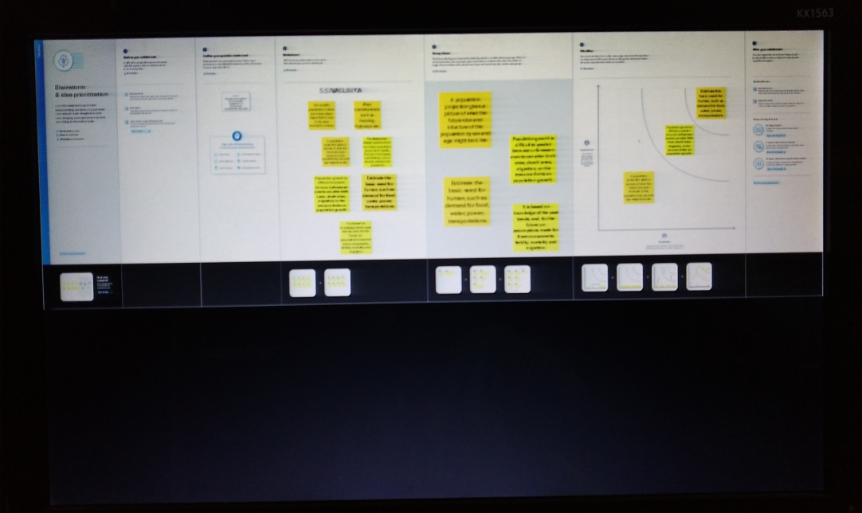

1. **RESULTS:**

Created sheets on tableau and dashboard and then created stories then published it on tableau public account.

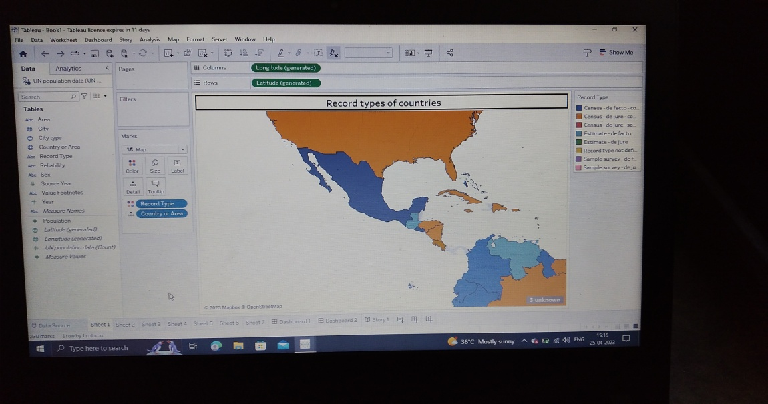

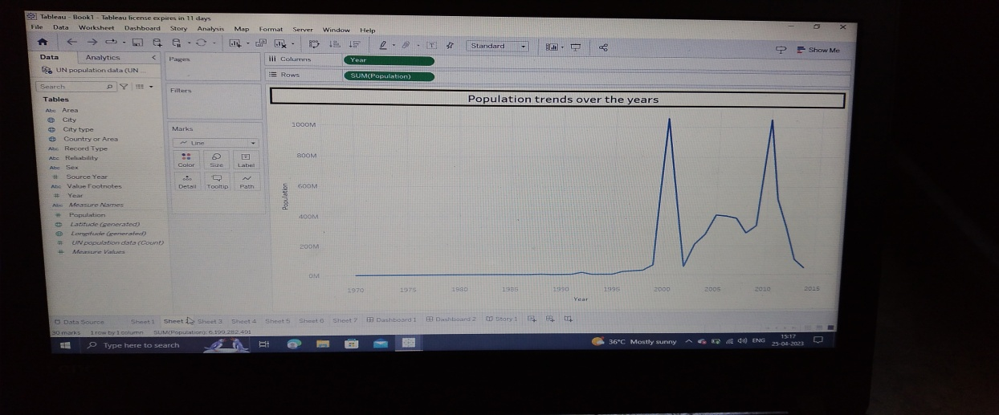

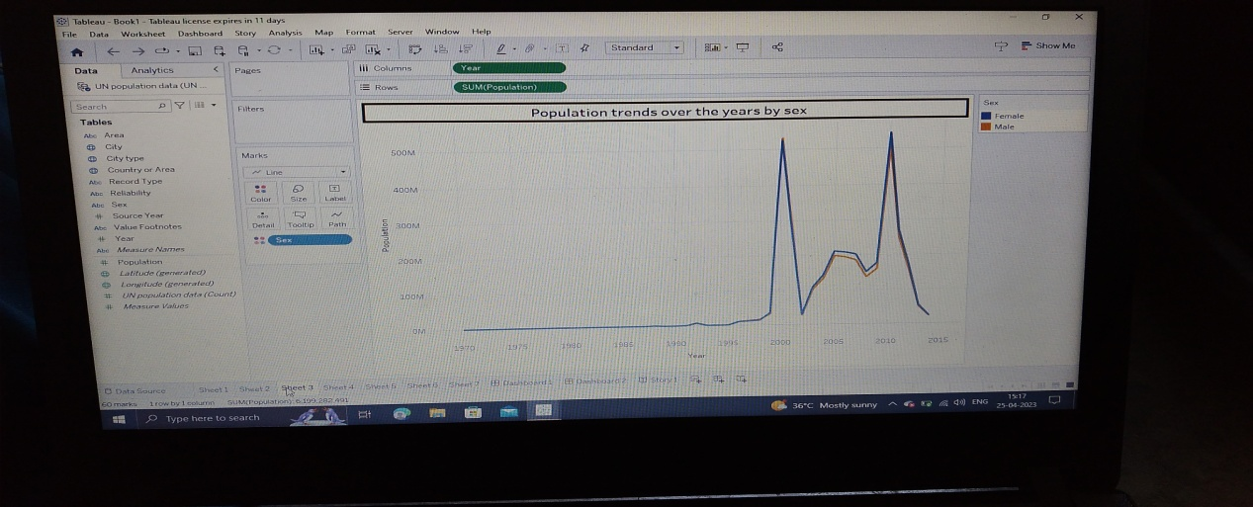

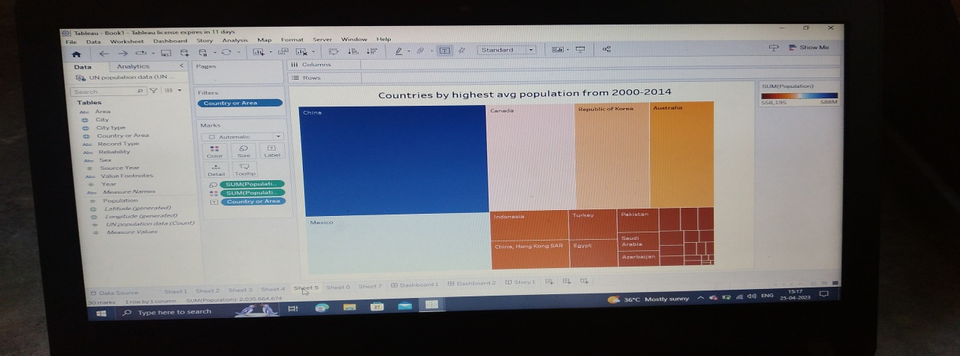

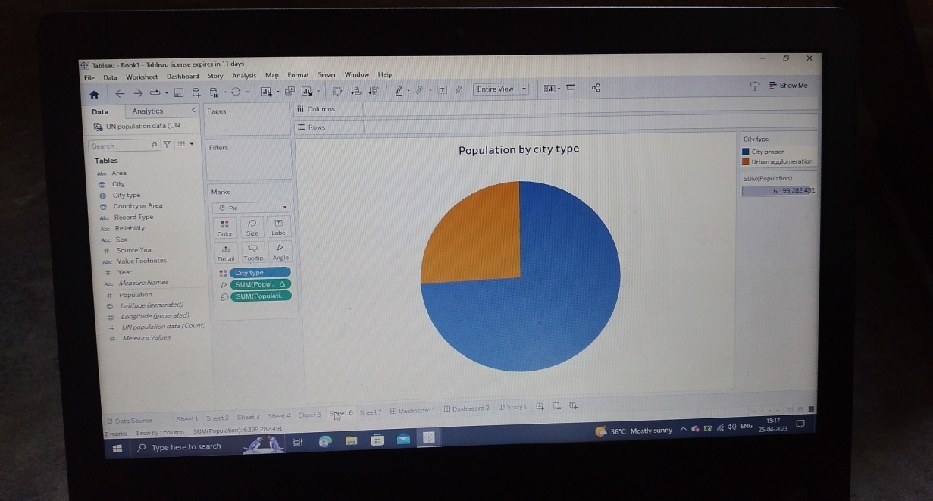

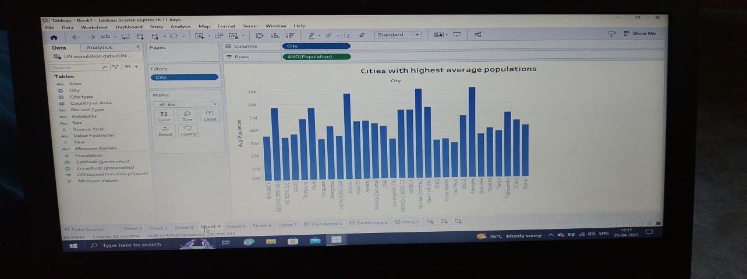





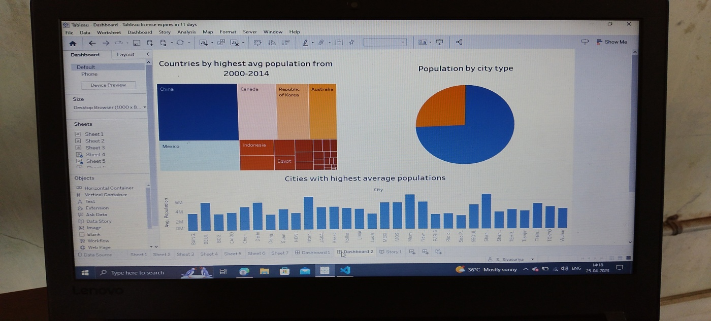

**ADVANTAGES :**

1. **More people leads to greater human capital**. If there are more people, the probability of finding a genius like Einsterin, Marie Curie, Beethoven increase. These exceptional people can lead to technological and cultural masterpieces which enrich our lives. The past 200 years have shown exponential growth in technical development and innovation. There are many factors behind this, but the world’s growing population means we have a bigger pool of human capital and the possibility of these cutting edge discoveries increase.

**2. Higher economic growth**. Population growth will lead to economic growth with more people able to produce more goods. It will lead to higher tax revenues which can be spent on public goods, such as health care and environmental projects.

* The obvious evaluation is to say, the crucial thing is not GDP, but [GDP per capita](https://www.economicshelp.org/blog/glossary/real-gdp-capita/). If economic growth is at the same rate as population growth, average living standards will not increase. However, it is possible population growth can also improve per capita incomes. As the population increases, the economy can benefit from a bigger talent pool, economies of scale and greater specialisation. All this can enable higher per capita income, which we have seen in major developed economies.

**3. The efficiency of higher population density**. In terms of per capita carbon footprint, areas with a high population density are significantly more efficient than rural areas and places with a low population. When people live in densely populated areas, they are more likely to use public transport, live in apartment buildings which are easier to heat. In big cities, transport and the delivery of goods is much more efficient, whereas for low population densities, the average cost and environmental footprint are much higher.  Therefore, population growth which leads to growth in city connurbations (which is a feature of global growth in past) is not as environmentally damaging as we may think. In [Green Metropolis](https://books.google.co.uk/books?id=Wkeu5PHQ_ygC&printsec=frontcover&dq=Green+Metropolis&hl=en&ei=lfjETqiuFuLq0gHbuMCeDw&sa=X&oi=book_result&ct=result&redir_esc=y#v=onepage&q&f=fals), by David Owen he argues living in closer proximity in cities is a key aspect of sustainability

* Urban areas account for only 3% of the world’s land surface. But, more than 50% of the population. By 2050, the [United Nations](https://web.archive.org/web/20220217170314/https:/www.un.org/development/desa/en/news/population/2018-revision-of-world-urbanization-prospects.html) predict this will rise to 70%. Therefore, population growth doesn’t have to lead to an equivalent fall in natural habitats.

**DISADVANTAGES:**

**1. Cost to the environment.** Population growth exacerbates many of the existing environmental problems

* Trying to reduce carbon and methane emissions to reduce global warming is relatively more difficult as the population.
* There will be greater threat on natural habitats as a greater population has greater demand for housing and farmland. This will increase pressure to cut down forests to make way for farming and housing.
* Higher population will lead to a greater consumption of non-renewable resources, leading to a faster depletion of natural resources.
* Higher population will lead to greater pollution levels in air, water and land. Higher pollution is associated with a range of health issues, such as cancer and asthma. The pollution also harms animals and plants.
* Soil degradation. To feed a growing planet, we have seen serious degrading of farmland (according to UN estimates) about 12 million hectares of farmland every year. This is due to factors, such as overgrazing, use of chemicals, climate change and use of chemicals.

1. **Congestion**. Too many people in a small space will lead to various types of congestion. Road congestion is a major problem across the world. One study suggested [congestion](https://igees.gov.ie/wp-content/uploads/2018/07/Cost-of-Congestion-Appendix-A-International-Evidence.pdf) cost the EU €111bn (1% of GDP) in 2012. WIth population growth, the costs of congestion will only increase leading to time lost, more pollution and lost output.

**3. Water shortages**. Already up to 40% of the world’s population face water scarcity and the risk of drought. According to  the [UN](https://www.unccd.int/actions/drought-initiative) water shortages could lead to 700 million people at the risk of displacement. A growing population will put pressure on scarce water supplies and this is a factor behind many minor and major conflicts with countries having to find ways around the shortage of water.

**APPLICATIONS:**

Population viability analysis (PVA) is used to estimate the likelihood of a population’s extinction and indicate the urgency of recovery efforts, and identify key life stages or processes that should be the focus of recovery efforts. PVA is also used to identify factors that drive population dynamics, compare proposed management options and assess existing recovery efforts. PVA is frequently used in [endangered species](https://en.wikipedia.org/wiki/Endangered_species) management to develop a plan of action, rank the pros and cons of different management scenarios, and assess the potential impacts of habitat loss.

**CONCLUSION:**

The Earth's current population is almost 7.6 billion people, and it is expanding. It is expected to surpass 8 billion people by 2025, 9 billion by 2040, and 11 billion by 2100. The population is quickly increasing, far surpassing our planet's ability to maintain it, given existing habits. Population growth is the increase in the number of humans on Earth. For most of human history our population size was relatively stable. But with innovation and industrialization, energy, food, water, and medical care became more available and reliable.

**FUTURE SCOPES:**

The world's population is expected to increase by nearly 2 billion persons in the next 30 years, from the current 8 billion to 9.7 billion in 2050 and could peak at nearly 10.4 billion in the mid-2080s. The median estimate for future growth sees the world population reaching 8.6 billion in 2030, 9.8 billion in 2050 and 11.2 billion by 2100 assuming a continuing decrease in average fertility rate from 2.5 births per woman in 2010–2015 to 2.2 in 2045–2050 and to 2.0 in 2095–2100, according to the medium-variant .